***Part-1: Implementing the pom for the website:***

***Task-1:***

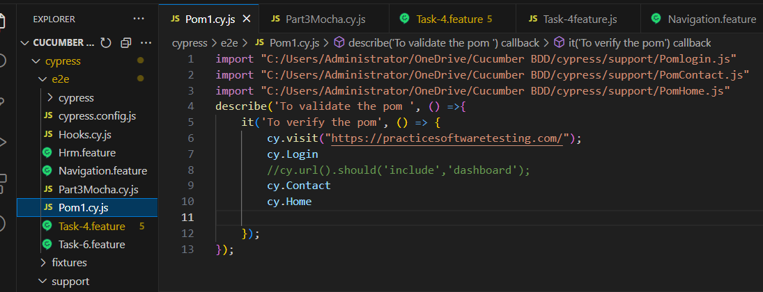

***.Json file POM:***

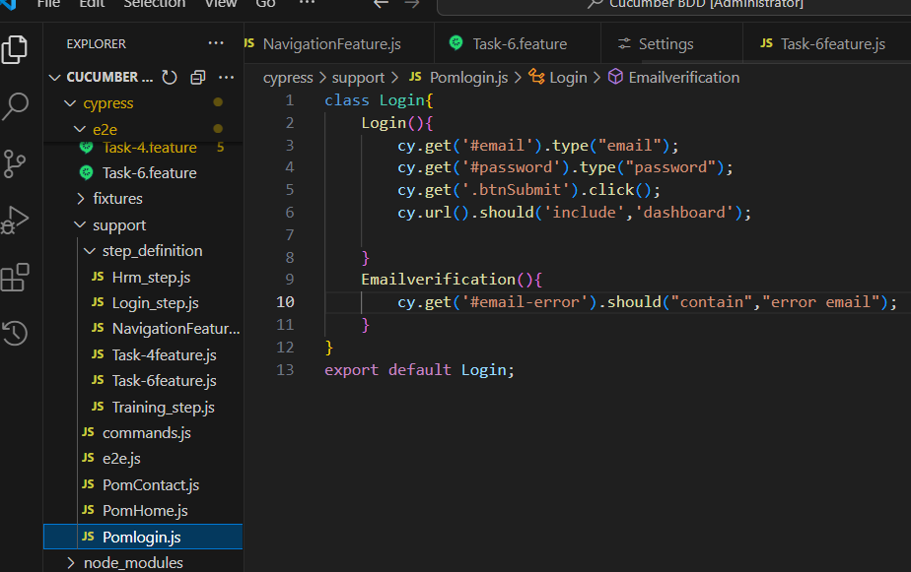

***Contact Pom .js:***

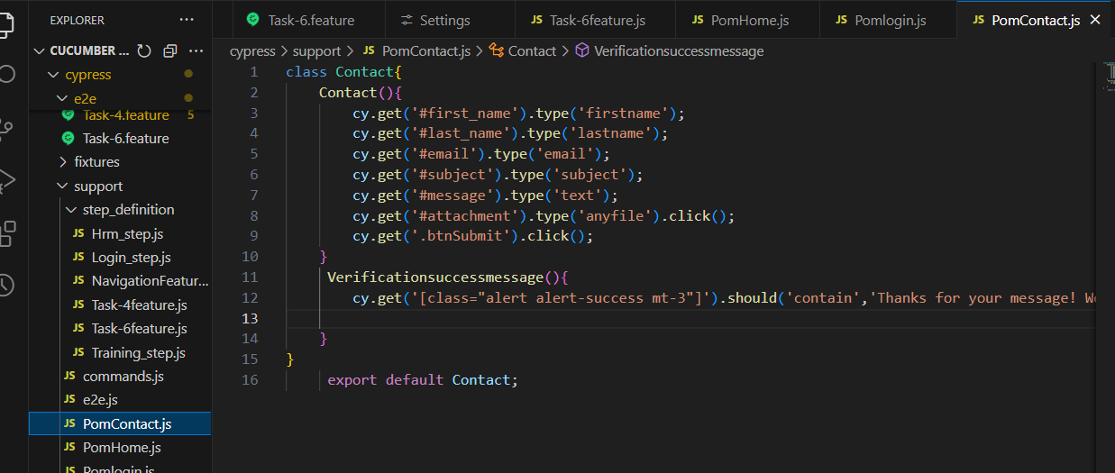

***Home POM .js:***

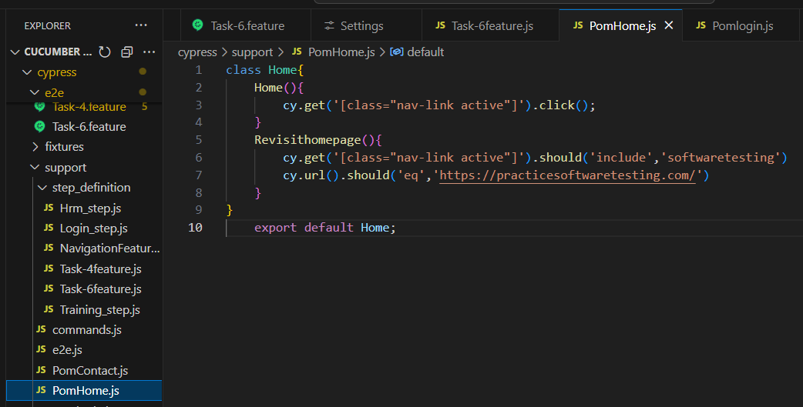

***Part-3: Advanced testing with Mocha:***

***Task-3:***

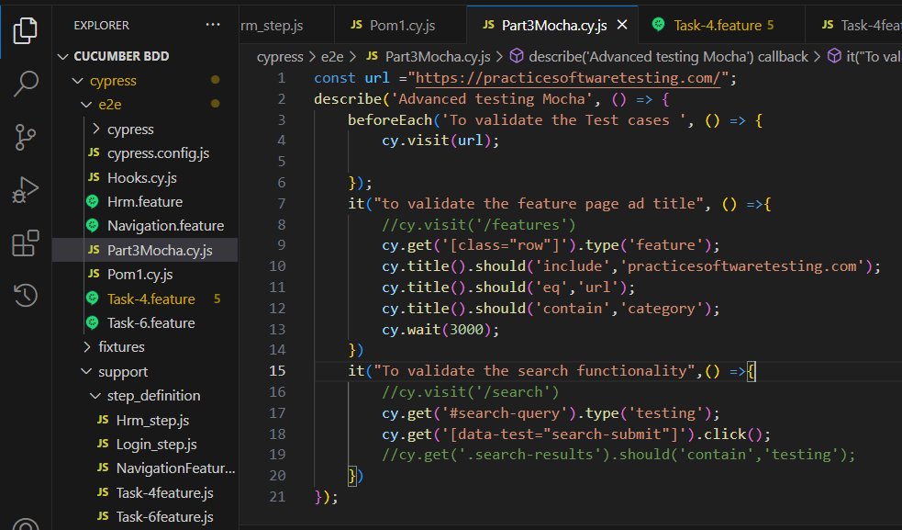

***Part-4: Writing scenarios using Gherkin:***

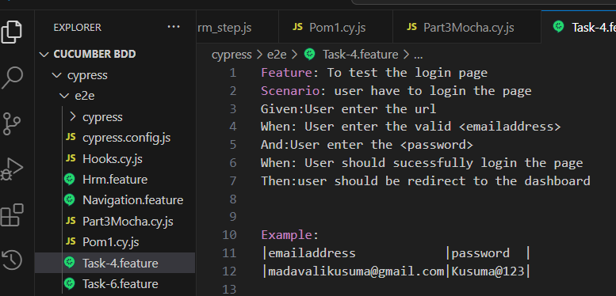

***Step_definitions :***

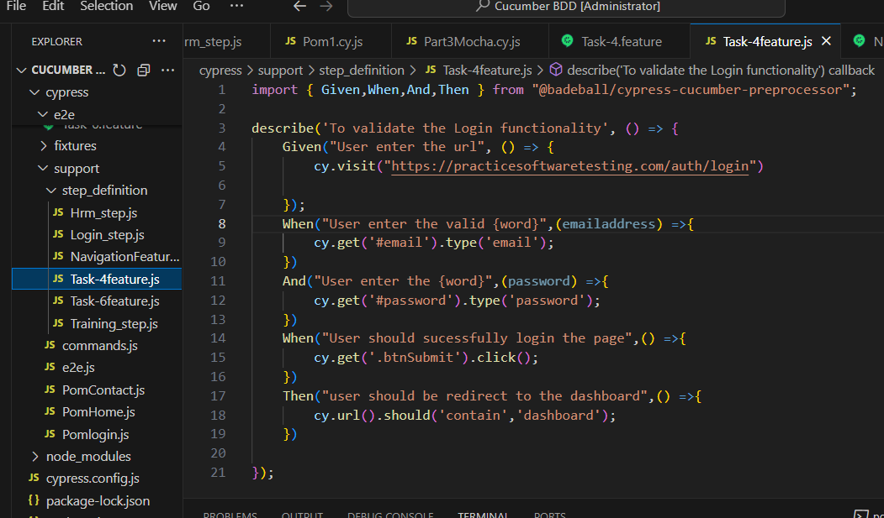

***Part-6: Advanced cypress techniques:***

***Task:***

***Implement cucumber test scenarios:***

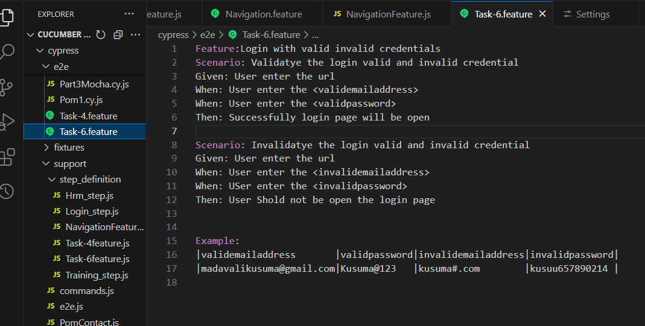

***Step_definition file:***

